
`

IBM Z

3932 System Cabling Best Practices (Rack Mount)




Contents
Chapter 1. Introduction 1
Chapter 2. Cable Support Recommendations 1
Clips 1
Hook-and-Loop Fastener 2
Chapter 3. Internal System Cables 8
Ethernet Network Cables 8
Power Supply Cords 8
SMP Cables 10
PCIe+ I/O Cable 10
Chapter 4. External System Cables 11
FICON & FCP Cables 11
OSA Network Cables 13
External Ethernet 13
Time Synchronization 14
Appendix A. Notices 16
Trademarks 17
Class A Notices 17

Chapter 1. Introduction
This cabling best practices document was created to help the reader lay out and retain cables for the mainframe. This document includes information for both internal and external cables to assist in both the initial system installation, system upgrades as well as external connections. Here, internal cables are those considered to remain within the system’s confines while external cables are considered cables that leave a frame. To ensure system reliability and serviceability, the reader must follow the contents of this document. It serves as a supplement for the Installation Manual for Physical Planning (IMPP). For essential information including, but not limited to, safety notices, specifications, power requirements, and hardware management, refer to the IMPP. STP and Visio files are also available as visualization tools.

Chapter 2. Cable Support Recommendations

Clips

The system comes equipped with clips attached to the power supply units. It is intended to retain the power supply cords.

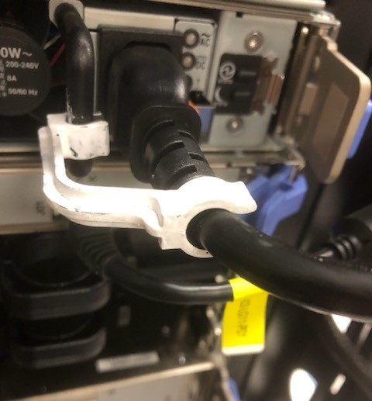
Figure 1: Small Power Supply Unit Clip

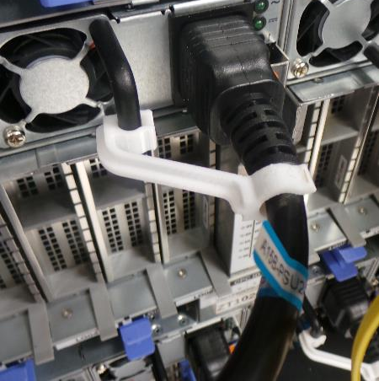
Figure 2: Large Power Supply Unit Clip

Hook-and-Loop Fastener

Hook-and-loop fasteners are used to properly route and retain cables in place, while maintaining bend radii and strain relief. Figure 3 shows what hook-and-loop fasteners look like.

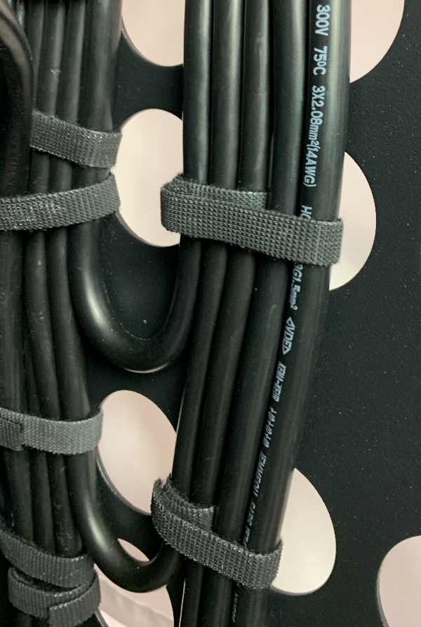
Figure 3: Hook-and-Loop Fastener

Images (4-9) are examples on how to best route and retain the cables. Client frames may vary as well as pre-existing cables and/or features. In general, it is best to take a layered approach to installing cables starting with power, then signal, and finally optical. These cables are to be routed at install before plugging to prevent any unplugging issues. Cables that impede system serviceability is strongly discouraged. Therefore, cables on the right should be routed to the right, and cables on the left are to be routed left. The bend radius is to be maintained throughout the routing process. The IMPP goes into further details about servicing systems.

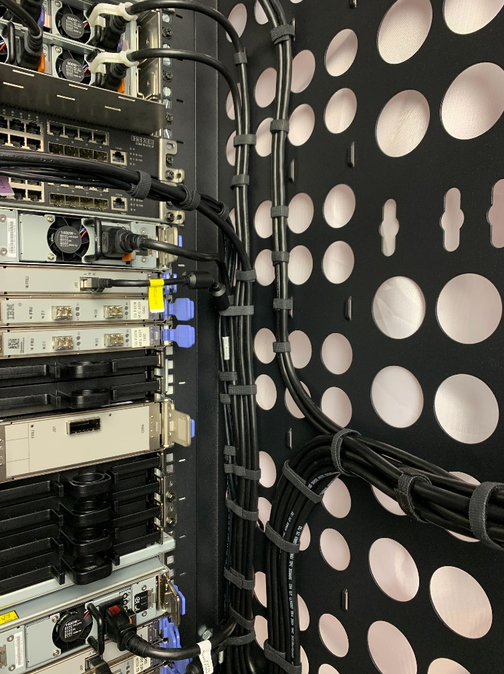
Figure 4

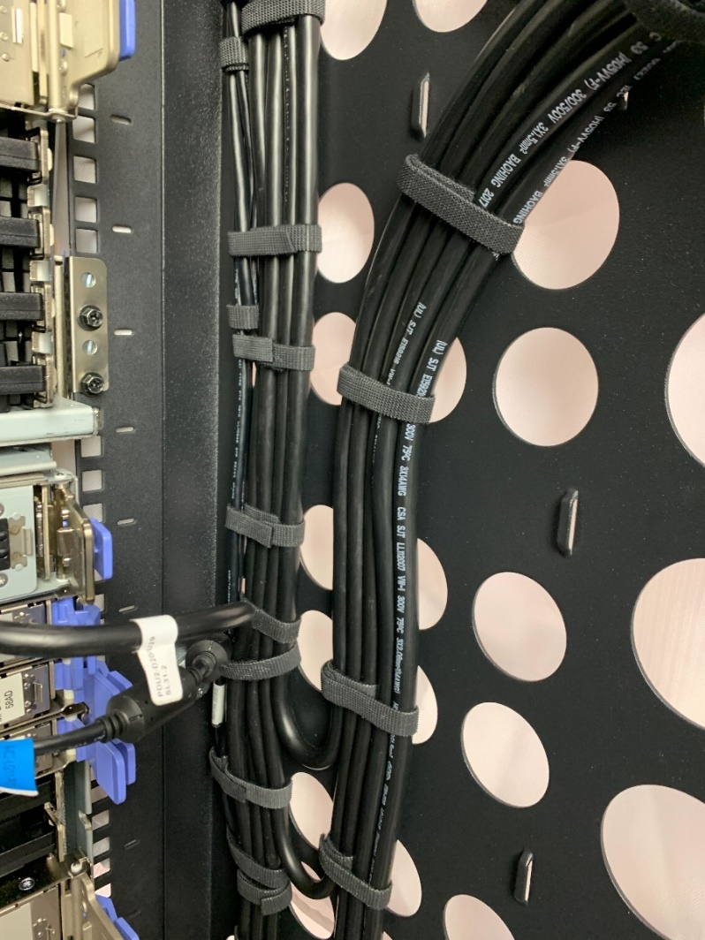
Figure 5

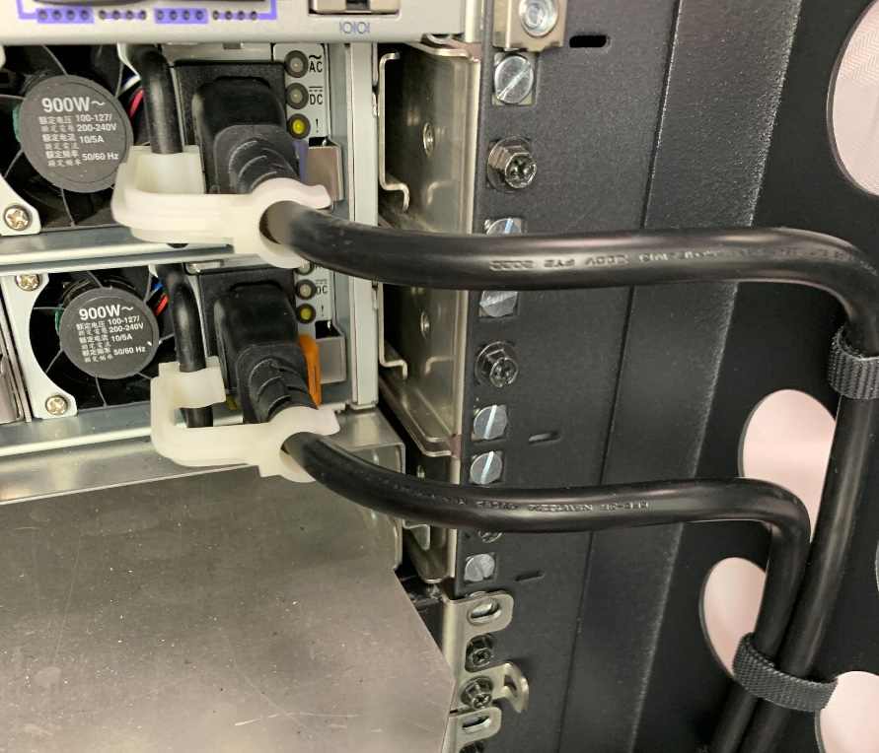
Figure 6

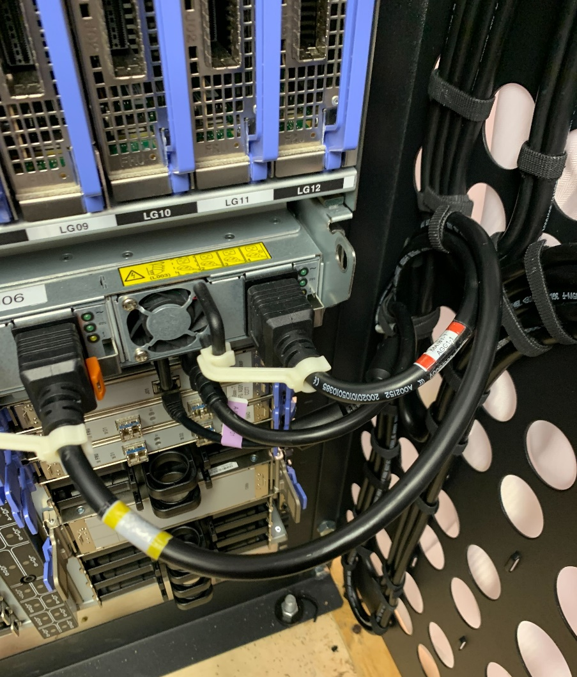
Figure 7

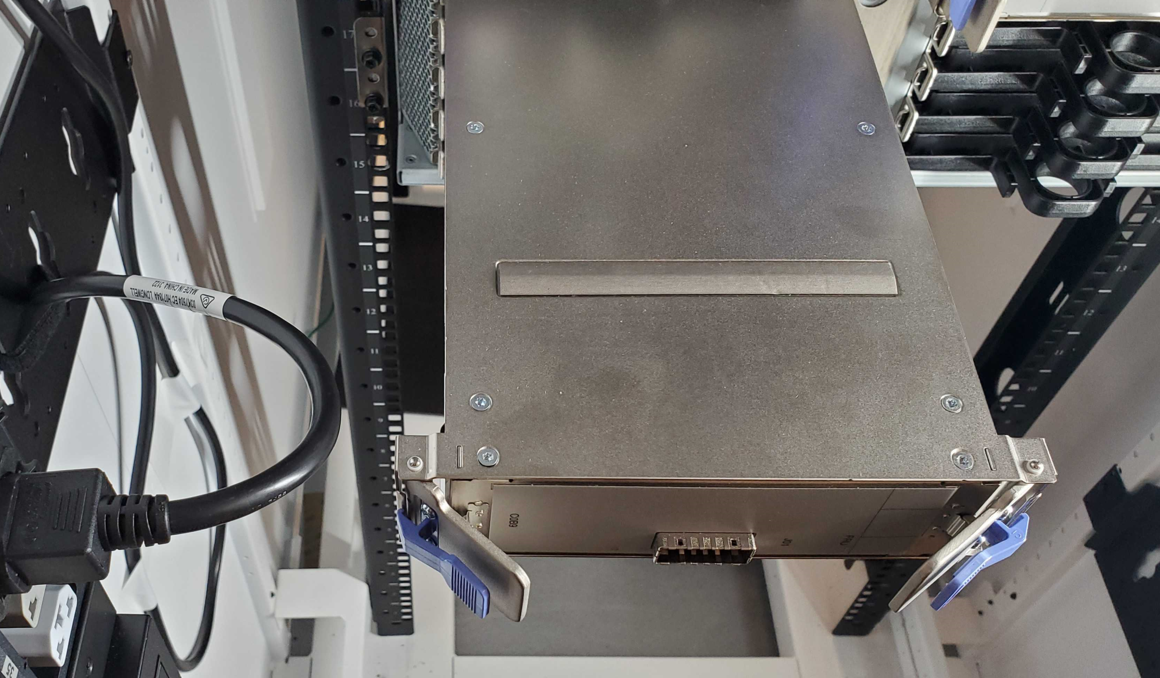
Figure 8

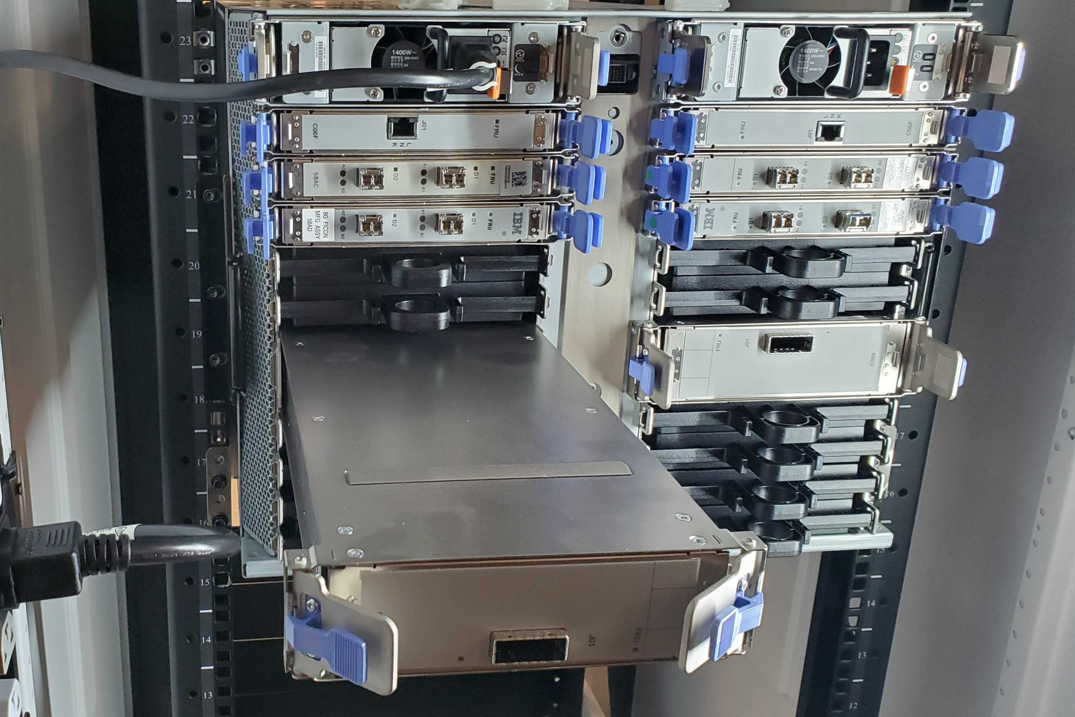
Figure 9

Chapter 3. Internal System Cables

Signal and power cables are routed within a frame. For each cable, there is a striped or solid location flag label for guidance as to where the cable should be plugged. The color on the labels serves as a visual aid to distinguish entities from each other. The solid indicates the primary source and the stripe indicates the secondary source. Operators should read the printed label data to ensure the correct plugging location. The subsequent sections are ordered the same way the cables are to be installed.

Ethernet Network Cables

Internal system ethernet network cables interconnect the system’s internal service processor network. Some ethernet cables will have two (2) ferrite cores, and others will not. External ethernet cables will be discussed later in this document.

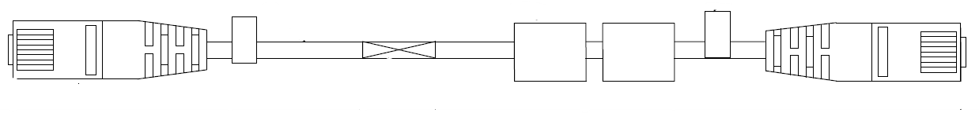
Figure 10: 2D Drawing of an Ethernet Cable

Power Supply Cords
Power supply cords are used to connect the internal power supply units to the system’s Power Distribution Unit (PDU).

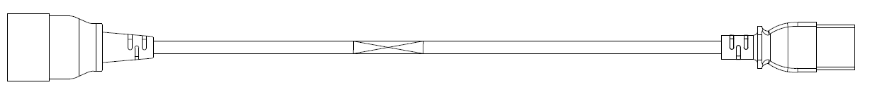
Figure 11: 2D Drawing of a Power Supply Cord

The customer can choose the best power supply cord length for their rack. To assist with the selection process, a cable matrix was developed to identify edge cases. It takes into consideration frames up to 50U, vertical (0U) PDUs approximately 6U in length, and horizontal (1U and 2U) PDUs. If the customer has a vertical PDU that spans the height of the rack, then the cable length should be chosen based on section that the port is in. Even though there are many possible configurations, the cable matrix can be used as a guide to find the best length for given areas. The following diagram is used to depict the relative PDU positions used in the cable matrix.

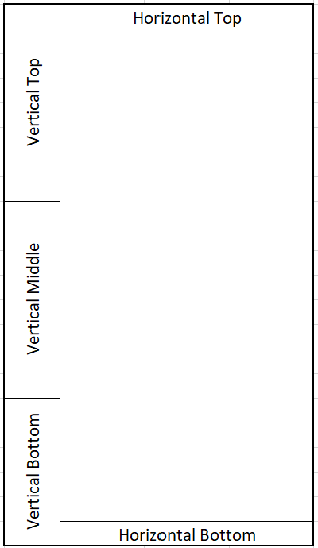
Figure 12: Relative PDU Positions for the Cable Matrix

The cable matrix is to be read left to right. First, the reader should choose an IBM component, next, the EIA location where it will be placed in, and finally find an appropriate length based on where the PDU is located and its orientation.

Figure 13: Cable Matrix

SMP Cables

SMP cables create the processor network by connecting the nodes of the CPC drawer.

Note: For PDU service actions, the hook-and-loop fastener that retains the SMP cable will need to be removed to release the cable, so they can be moved out of the way during servicing. DO NOT unplug the cable, but gently move it aside to make clearance for service activities.

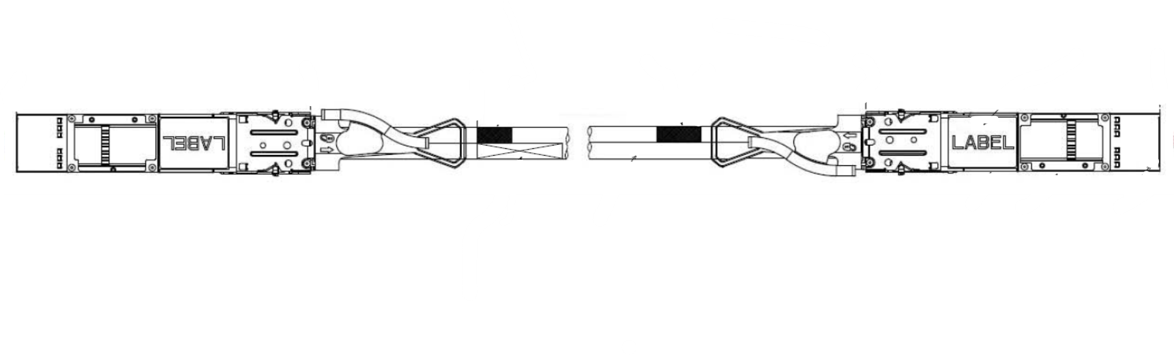
Figure 14: 2D Rendering of SMP Cable

PCIe+ I/O Cable

PCIe+ I/O cables connect the CPC drawers to the PCIe+ I/O drawers.

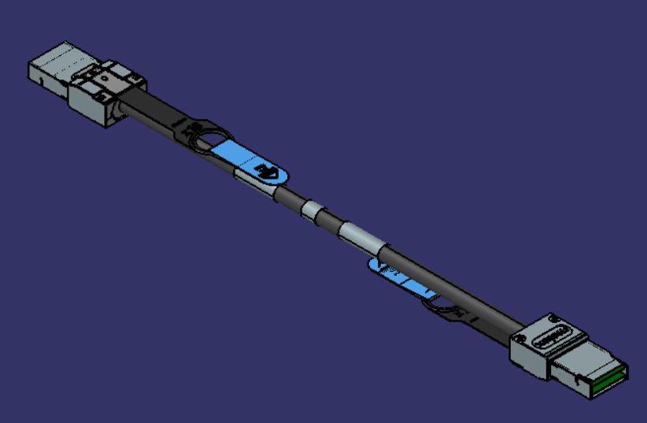
Figure 15: 3D Rendering of a PCIe+ I/O Cable

Chapter 4. External System Cables

FICON & FCP Cables

Fiber optic cables that attach to PCIe+ I/O cards can exit through the top or the bottom of the frame. FICON Express, OSA Express, and Coupling connection types are included in this grouping for further details on the connection type options, refer to the IMPP chapter on I/O Cabling and Connectivity. For planning, there is a Planning for Fiber Optic Links document available on Resource Link. When installing fiber optic cables, it is important to follow the recommended cleaning and installation procedures for all fiber optic cable products for optimal performance

FICON Cables

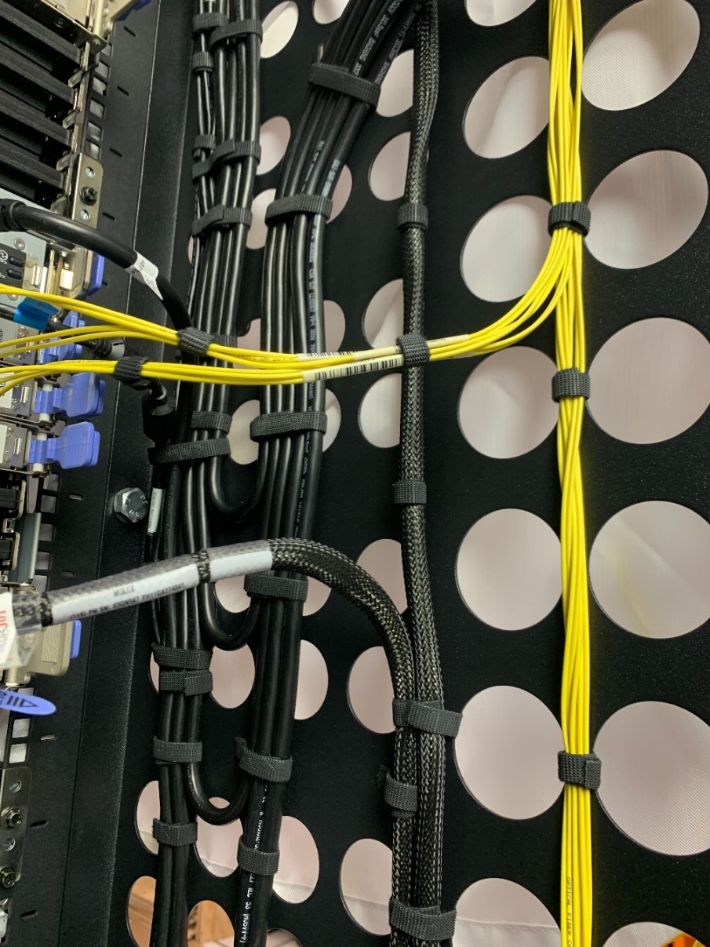
Figure 16

OSA Network Cables

Open Systems Adapter-Express (OSA-Express) features enable connectivity to industry-standard local area networks (LANs). These cables may either be copper or fiber optic. They are to be routed on the outer most layer of cable types. This is done to ensure the integrity of the cable as they are the most fragile. Configuration information is found in the IMPP and reference information is found in the Planning for Fiber Optic Links.

External Ethernet

There are two (2) 50-foot external ethernet cables provided that connect the Support Element (SE) to the Hardware Management Console (HMC). These cables are to be routed to the left of the server then exit either from the top or the bottom depending on the external cabling configuration.

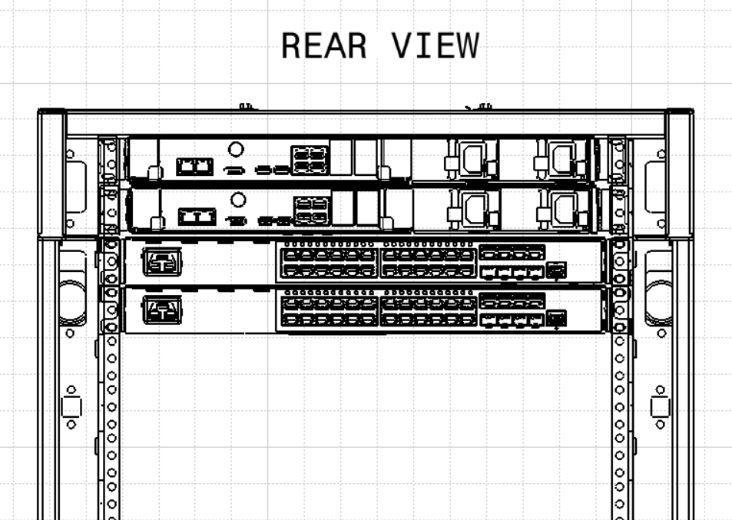
Figure 17: External Ethernet Routing

Time Synchronization

A Server Time Protocol (STP) Coordinated Timing Networks (CTN) has the capability of connecting to its time source a Network Time Protocol (NTP) time server that has a Pulse Per Second (PPS) output signal. This type of external timing device is connected using a coaxial cable to the front of the CPC drawer (reference Figures 18 and 19). The cable should be retained to the FSP card latches using hook-and-loop fasteners.

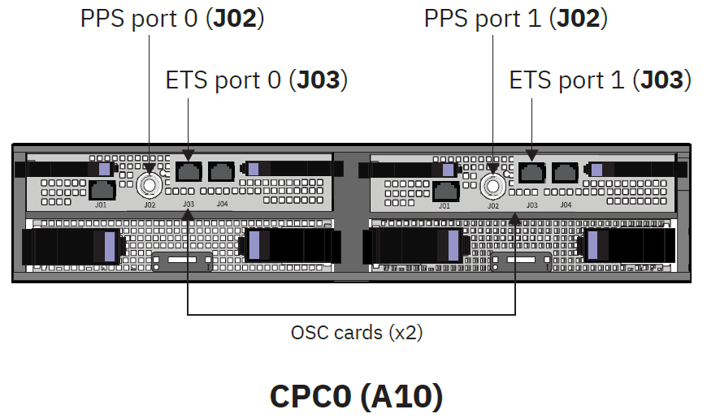
Figure 18: PPS Ports for One (1) CPC drawer

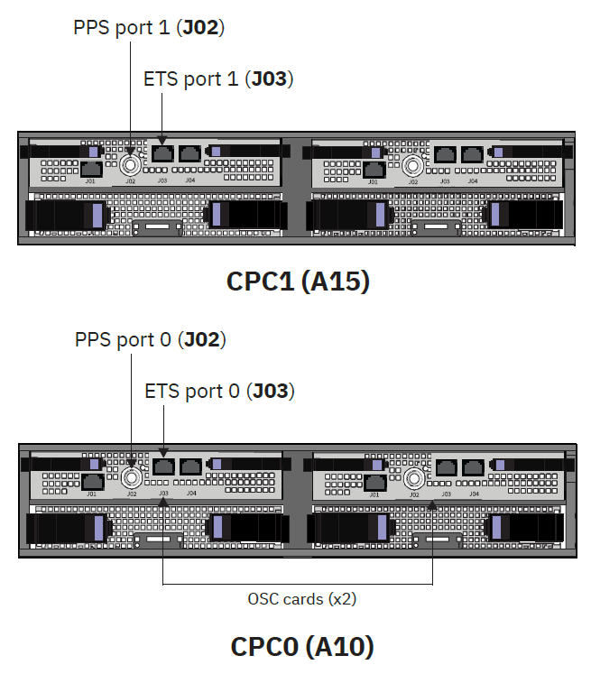
Figure 19: PPS Ports for Two (2) CPC drawers

Appendix A. Notices

This information was developed for products and services offered in the US.
IBM may not offer the products, services, or features discussed in this document in other countries. Consult your local IBM representative for information on the products and services currently available in your area. Any reference to an IBM product, program, or service is not intended to state or imply that only that IBM product, program, or service may be used. Any functionally equivalent product, program, or service that does not infringe any IBM intellectual property right may be used instead. However, it is the user's responsibility to evaluate and verify the operation of any non-IBM product, program, or service.
IBM may have patents or pending patent applications covering subject matter described in this document. The furnishing of this document does not grant you any license to these patents. You can send license inquiries, in writing, to:
IBM Director of Licensing
IBM Corporation
North Castle Drive, MD-NC119
Armonk, NY 10504-1785
US
INTERNATIONAL BUSINESS MACHINES CORPORATION PROVIDES THIS PUBLICATION "AS IS" WITHOUT WARRANTY OF ANY KIND, EITHER EXPRESS OR IMPLIED, INCLUDING, BUT NOT LIMITED TO, THE IMPLIED WARRANTIES OF NON-INFRINGEMENT, MERCHANTABILITY OR FITNESS FOR A
PARTICULAR PURPOSE. Some jurisdictions do not allow disclaimer of express or implied warranties in certain transactions, therefore, this statement may not apply to you.
This information could include technical inaccuracies or typographical errors. Changes are periodically made to the information herein; these changes will be incorporated in new editions of the publication. IBM may make improvements and/or changes in the product(s) and/or the program(s) described in this publication at any time without notice.
Any references in this information to non-IBM websites are provided for convenience only and do not in any manner serve as an endorsement of those websites. The materials at those websites are not part of the materials for this IBM product and use of those websites is at your own risk.
IBM may use or distribute any of the information you provide in any way it believes appropriate without incurring any obligation to you.
Information concerning non-IBM products was obtained from the suppliers of those products, their published announcements or other publicly available sources. IBM has not tested those products and cannot confirm the accuracy of performance, compatibility or any other claims related to non-IBM products. Questions on the capabilities of non-IBM products should be addressed to the suppliers of those products.
Statements regarding IBM's future direction or intent are subject to change or withdrawal without notice, and represent goals and objectives only.
This information contains examples of data and reports used in daily business operations. To illustrate them as completely as possible, the examples include the names of individuals, companies, brands, and products. All of these names are fictitious and any similarity to actual people or business enterprise is entirely coincidental.

Trademarks
IBM, the IBM logo, and ibm.com® are trademarks of International Business Machines Corp., registered in many jurisdictions worldwide. Other product and service names might be trademarks of IBM or other companies. A current list of IBM trademarks is available on the web at "Copyright and trademark information" at http://www.ibm.com/legal/copytrade.
Linux is a registered trademark of Linus Torvalds in the United States, other countries, or both.
Microsoft and Windows are trademarks of Microsoft Corporation in the United States, other countries, or both.

Class A Notices
The following Class A statements apply to this IBM product. The statement for other IBM products intended for use with this product will appear in their accompanying manuals.

Federal Communications Commission (FCC) Statement
Note: This equipment has been tested and found to comply with the limits for a Class A digital device, pursuant to Part 15 of the FCC Rules. These limits are designed to provide reasonable protection against harmful interference when the equipment is operated in a commercial environment. This equipment generates, uses, and can radiate radio frequency energy and, if not installed and used in accordance with the instruction manual, may cause harmful interference to radio communications. Operation of this equipment in a residential area is likely to cause harmful interference, in which case the user will be required to correct the interference at his own expense.
Properly shielded and grounded cables and connectors must be used in order to meet FCC emission limits. IBM is not responsible for any radio or television interference caused by using other than recommended cables and connectors or by unauthorized changes or modifications to this equipment. Unauthorized changes or modifications could void the user's authority to operate the equipment.
This device complies with Part 15 of the FCC rules. Operation is subject to the following two conditions:
- this device may not cause harmful interference, and (2) this device must accept any interference received, including interference that may cause undesired operation.

Industry Canada Compliance Statement
This Class A digital apparatus complies with Canadian ICES-003.

Avis de conformité à la réglementation d'Industrie Canada
Cet appareil numérique de la classe A est conforme à la norme NMB-003 du Canada.

European Community Compliance Statement
This product is in conformity with the protection requirements of EU Council Directive 2014/30/EU on the approximation of the laws of the Member States relating to electromagnetic compatibility. IBM cannot accept responsibility for any failure to satisfy the protection requirements resulting from a non- recommended modification of the product, including the fitting of non-IBM option cards.

This product has been tested and found to comply with the limits for Class A Information Technology Equipment according to European Standard EN 55032. The limits for Class A equipment were derived for commercial and industrial environments to provide reasonable protection against interference with licensed communication equipment.
European Community contact:
IBM Deutschland GmbH
Technical Regulations, Department M372 IBM-Allee 1, 71139 Ehningen, Germany
Tele: +49 (0) 800 225 5423 or +49 (0) 180 331 3233
email: halloibm@de.ibm.com
Warning: This is a Class A product. In a domestic environment, this product may cause radio interference, in which case the user may be required to take adequate measures.

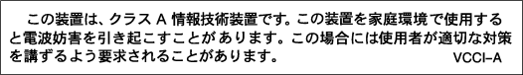
VCCI Statement - Japan
The following is a summary of the Japanese VCCI statement above:
This is a Class A product based on the standard of the VCCI Council. If this equipment is used in a domestic environment, radio interference may occur, in which case the user may be required to take corrective actions.

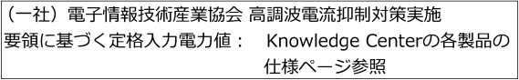
Japan JIS C 61000-3-2 Compliance
For products less than or equal to 20 A per phase, the following statement applies:
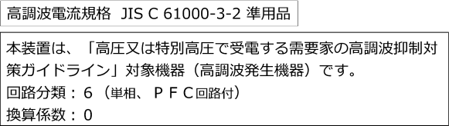
For products greater than 20 A, single-phase, the following statements apply:
For products greater than 20 A per phase, three-phase, the following statements apply:

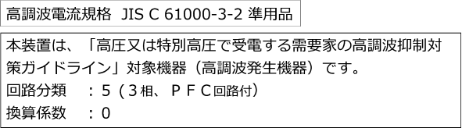

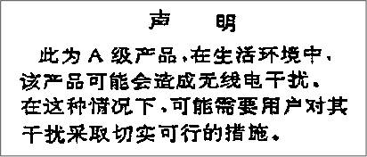
Electromagnetic Interference (EMI) Statement - People's Republic of China

Declaration: This is a Class A product. In a domestic environment, this product may cause radio interference, in which case the user may need to perform practical action.


Electromagnetic Interference (EMI) Statement - Taiwan
The following is a summary of the Taiwan EMI statement above:
Warning: This is a Class A product. In a domestic environment, this product may cause radio interference, in which case the user will be required to take adequate measures.
IBM Taiwan Contact Information:




Electromagnetic Interference (EMI) Statement - Korea

Germany Compliance Statement
Deutschsprachiger EU Hinweis: Hinweis für Geräte der Klasse A EU-Richtlinie zur Elektromagnetischen Verträglichkeit
Dieses Produkt entspricht den Schutzanforderungen der EU-Richtlinie 2014/30/EU zur Angleichung der Rechtsvorschriften über die elektromagnetische Verträglichkeit in den EU-Mitgliedsstaaten und hält die Grenzwerte der EN 55032 Klasse A ein.
Um dieses sicherzustellen, sind die Geräte wie in den Handbüchern beschrieben zu installieren und zu betreiben. Des Weiteren dürfen auch nur von der IBM empfohlene Kabel angeschlossen werden. IBM übernimmt keine Verantwortung für die Einhaltung der Schutzanforderungen, wenn das Produkt ohne Zustimmung von IBM verändert bzw. wenn Erweiterungskomponenten von Fremdherstellern ohne Empfehlung von IBM gesteckt/eingebaut werden.
EN 55032 Klasse A Geräte müssen mit folgendem Warnhinweis versehen werden:
"Warnung: Dieses ist eine Einrichtung der Klasse A. Diese Einrichtung kann im Wohnbereich Funk- Störungen verursachen; in diesem Fall kann vom Betreiber verlangt werden, angemessene Maßnahmen zu ergreifen und dafür aufzukommen."
Deutschland: Einhaltung des Gesetzes über die elektromagnetische Verträglichkeit von Geräten
Dieses Produkt entspricht dem "Gesetz über die elektromagnetische Verträglichkeit von Geräten (EMVG)". Dies ist die Umsetzung der EU-Richtlinie 2014/30/EU in der Bundesrepublik Deutschland.
Zulassungsbescheinigung laut dem Deutschen Gesetz über die elektromagnetische Verträglichkeit von Geräten (EMVG) (bzw. der EMC EG Richtlinie 2014/30/EU) für Geräte der Klasse A
Dieses Gerät ist berechtigt, in Übereinstimmung mit dem Deutschen EMVG das EG-Konformitätszeichen - CE - zu führen.
Verantwortlich für die Einhaltung der EMV Vorschriften ist der Hersteller: International Business Machines Corp.
New Orchard Road Armonk, New York 10504 Tel: 914-499-1900
Der verantwortliche Ansprechpartner des Herstellers in der EU ist: IBM Deutschland GmbH
Technical Regulations, Abteilung M372 IBM-Allee 1, 71139 Ehningen, Germany
Tel: +49 (0) 800 225 5423 or +49 (0) 180 331 3233
email: halloibm@de.ibm.com

Generelle Informationen:
Das Gerät erfüllt die Schutzanforderungen nach EN 55024 und EN 55032 Klasse A.

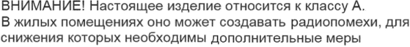
Electromagnetic Interference (EMI) Statement - Russia

